**Recession Analysis Report**

**Overview**

The Great Recession that began in December 2007 was believed to be the worst economic downturn the country had experienced since the Great Depression. The pandemic was accompanied by historic drops in output in almost all major economies. My objective is to analyze the impact of global financial crisis and pandemic crisis in terms of

* Labor force participation rate/Participation rate/activity rate - measure of percentage of Americans who are in the labor force including the people who are actively seeking jobs,
* Unemployment rate - measures the percentage within the labor force that is currently without a job,
* Employed - individuals with a minimum required age who work during a certain time for a business,
* Unemployed - workers who do not have a job but are actively looking for work .

**Data**

The data was extracted from Federal Reserve Economic Data( <https://fred.stlouisfed.org/>>), an online database. The data includes unemployment rate for California, Florida and Texas, labor force participation rate by age , gender and race from 2004 to 2022. The reasons for choosing these states include high population and nice weather. Also, Texas and California are home to 20 percent of America and all these states are in the top 10 list of states with the biggest growth. The great recession that was from 2007-2009 and the pandemic that was from 2019-2020 was one of the worst in US history. My analysis here is to find if the two crises are similar or different in terms of factors mentioned above.

Results

During the 2007-09 recession,the unemployment rate more than doubled in the US.From the chart below, it’s clearly seen from the rate continued to increasing even after the recession ended in 2009 and fell to the lowest during pre-pandemic . The pandemic saw very quick sharp increase and increase in unemployment rate.

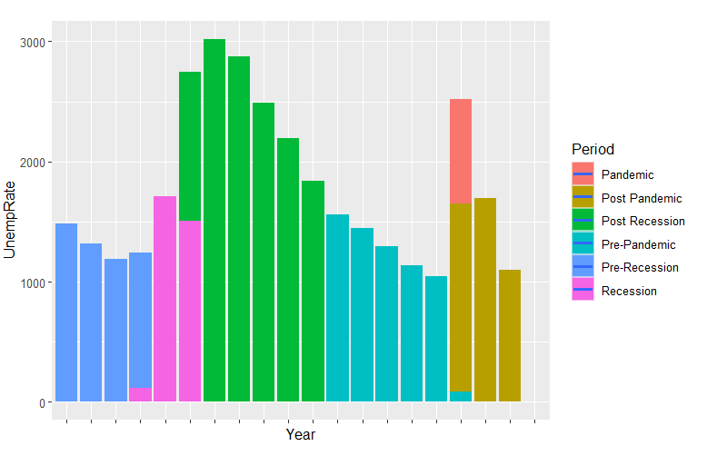

Pandemic saw an all time high average of 14%. in April of 2020. California topped the other two states in terms of having highest rate during both periods.

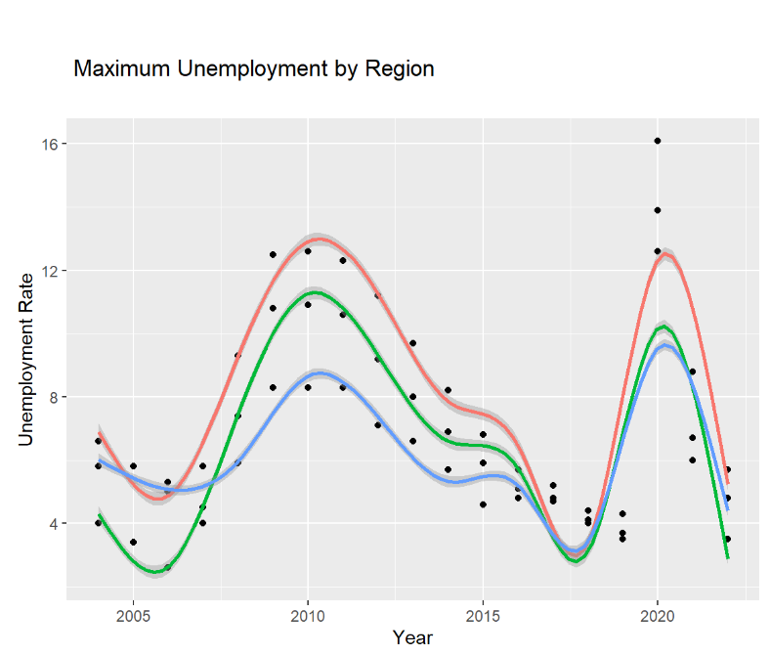

The pandemic and recession periods saw the participation rate decrease, with increased unemployment rate. Low participation rate during recession reflects the rising number of job losses. In a pandemic, it may be due to lack of job opportunities and fears of contracting the virus which lead to shrinking numbers in the labor force. The unemployment and participation rates across Florida, California and Texas exhibit similar trends of the US overall. Construction sector in Texas had more number of persons employed during pandemic.Manufacturing sector in California saw decrease in number of people employed during pandemic

The average participation rate during recession is close to 66%. All three states' average are either equal or one percent lower than the national average. Participation rate among men is higher than women and in particular men of age 25 to 54 years' activity rate is higher than all other age groups and it is lower among women of age 15 to 24 years.Hispanic participation rate is highest and African Americans’ participation rate is at the lowest during both periods.

**Conclusion**

From the analysis, it is seen that the effect of recession 2007 lingered over a long period of time Whereas effect of the 2019 pandemic induced recession was a short one. Evidence shows among gender, women and among race and African American get affected by the crisis disproportionately.